GitHub link: (includes all the files of the project AI chatbot App, a demo video of it)

The screenshot of the main app screens:

Main page:

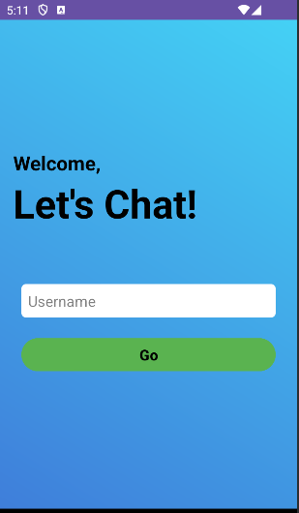

Chat page:

